Management and Policy

As far as the management itself is concerned, it can be defined as the act of control or supervision in an organization such as a school or any other educational institution. In the context of managing a digital school, another meaning of so-called management comes in useful, namely - the people who are in control, take decisions and have been given specific tasks regarding school digital strategy.

The infographic located below clearly shows what the structure of management in a school might be with the emphasis on tasks applying to digital learning:

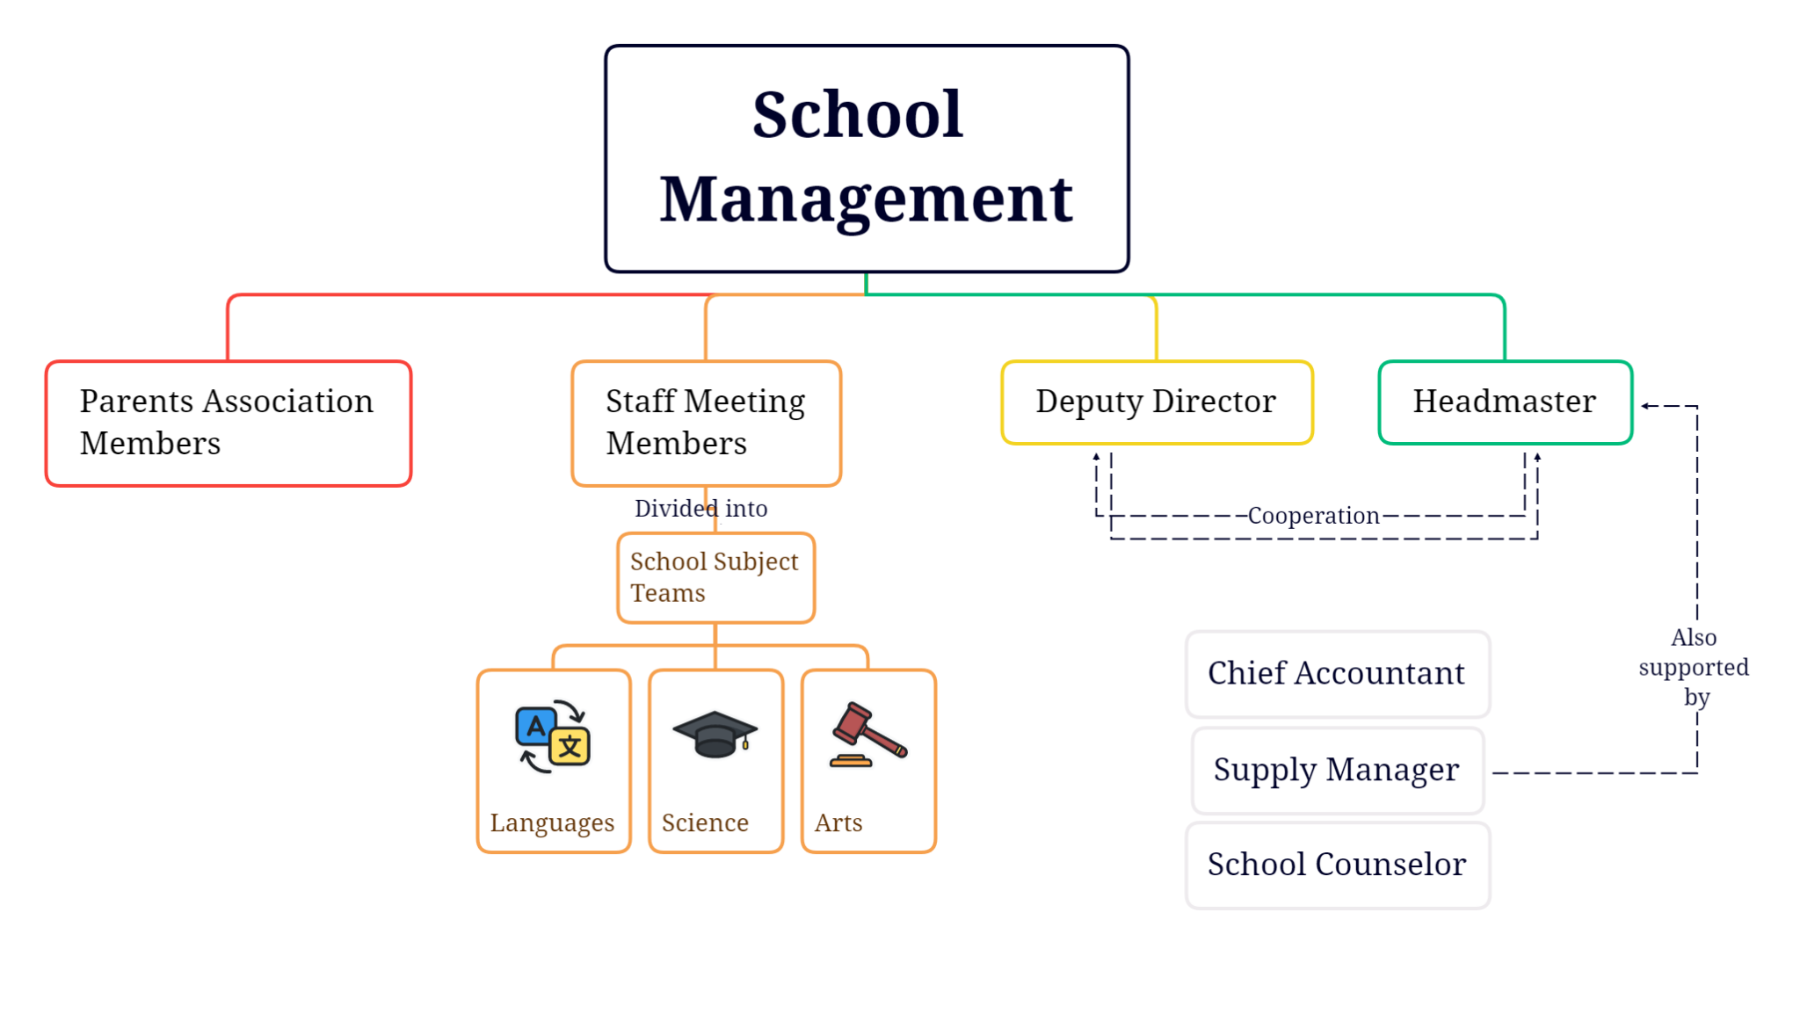

Tasks and responsibilities of a headmaster:

- they direct all school activities and represent it in external fora (as part of their tasks, he or she has financial means at their disposal that might be used to obtain modern electronic equipment in students’ transition to digital learning)
- they set specific guidelines for all teachers employed in the institution when it comes to materials and resources necessary to perform their job (in this case the materials and resources include devices needed to teach on-line, such as personal computers, laptops, iPads, cameras, microphones, etc)
- they support teachers in the process of professional development (various forms of internal and external courses or workshops extending their practical knowledge of specific tools/applications/websites, etc crucial in digital strategies)
- they supervise school documentation (including School Statutes and Computer Science Laboratory Specific Rules and Regulations)
- they are responsible for taking decisions regarding the functions of a deputy director and other positions of management
- they make sure students study in appropriate conditions and can develop as independent learners and competent users of all above mentioned electronic devices and programmes as well as applications needed to continue education on-line

Headmaster is supported by a deputy director, a chief accountant, a supply manager and the school counselor in any activities taken to lead the school to successful digital transformation.

Tasks and responsibilities of a deputy director:

- they manage school office and administrative panel of employees
- they observe classes, academic sessions and supervise the work and activity of school subject teams (observations on the effective use of electronic devices e.g. iPads on part of a teacher and their students are made)
- they take care of accurate inventory of school assets (electronic devices including)
- they inspire and organize the work of form teachers, especially in reference to class documentation (form teachers are trained to use various computer programs to enhance their work)

Tasks and responsibilities of school subject teams:

- divided according to school subject correlation (Foreign Languages Team, The Humanities Team, Combined Science Team, etc - the precise division enables teachers cooperating within a specific team to describe and diagnose problems regarding digital strategy and fluent digital transition)
- they organize activities of subject laboratories (Computer Science Laboratory, Foreign Languages Laboratory)
- they pronounce opinions on already prepared curricula as well as innovative and experimental strategies
- they coordinate the accomplishment of activities planned in every school year (within specific grades or the whole school community)

Tasks and responsibilities of Staff Meeting members

- responsible for realizing the School Statutes’ objectives regarding effective didactic and educational processes at school
- they express opinions on pedagogical innovations, school financial projects
- decisions are made collectively

Tasks and responsibilities of Parents’ Association members

- they pronounce opinions on the school financial plans presented by a headmaster as well as on effective education improvement plans of an educational institution

Undoubtedly, any activities undertaken by a headmaster, a deputy director or school subject teams’ leaders are regulated by both governmental policies and school internal rules. The second infographic presented below gives one an insight into the subject:

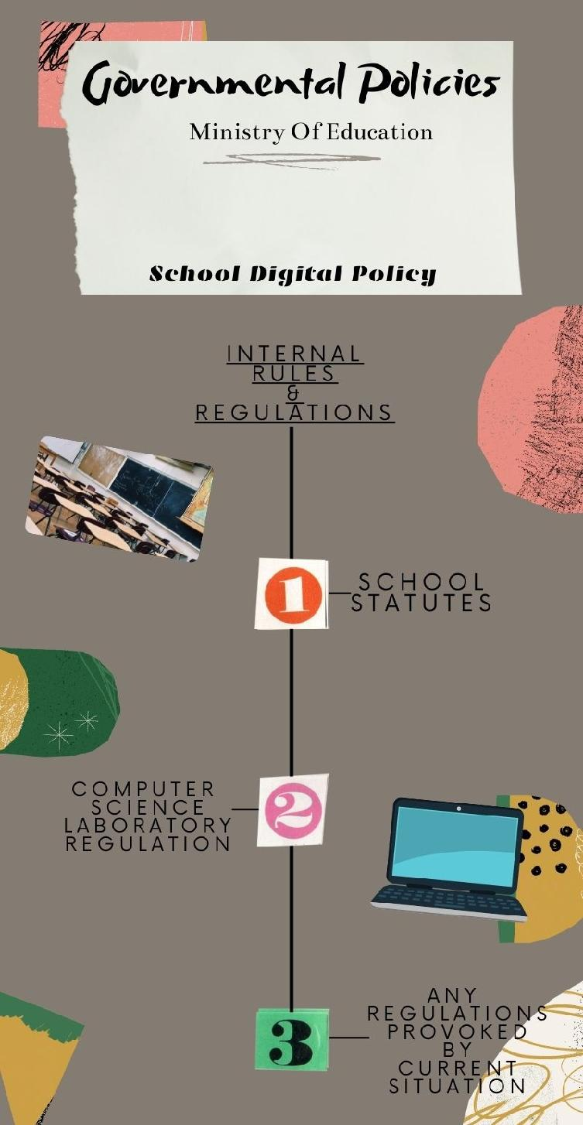

The governmental policies appear in the form of a plan or certain course of action describing guiding principles and procedures considered advantageous - most of all in challenging situations such as sudden switch to on-line education. The Ministry of Education provides all educational institutions within a country with all necessary information, often in the form of a prospectus outlining most important tendencies, practical solutions and useful links to websites (for further research).

Consequently, the school digital policy is actually based on the governmental policies regarding digital transition. It embraces School Statutes (pronouncing in detail all the tasks and responsibilities of a headmaster, deputy director, staff meeting members, parents association members, school subject teams, etc; supporting both rights and duties of teachers and students) and specific regulations (such as Computer Science Laboratory Rules and Regulations or regulations connected with some projects being implemented such as Digital School project).

GENERAL BENEFITS AND ADVANTAGES OF EFFECTIVE MANAGEMENT AND PRECISE POLICY

These might be summarized as follows:

- an educational institution (school of any type) has a clear and precise strategy, in other words code of conduct regarding digital transition (ruled and supervised by governmental regulations)
- professional duties and responsibilities are effectively divided among individuals and teams in order to avoid overlap in work and unnecessary waste of time and energy
- any school needs as far as the digital development might be concerned are accurately estimated (e.g. a number of electronic devices needed)
- an educational institution is well-prepared to implement effective measures of conduct in an emergency situation (such as sudden switch to on-line teaching in COVID-19 pandemic situation)
- students may grow and develop mentally, intellectually and emotionally having sense of safety due to the fact of their education being continued (constant access to electronic devices and necessary computer programs and applications under any circumstances)

CRUCIAL RECOMMENDATIONS AND IMPORTANT FACTORS TO CONSIDER WHEN PLANNING SCHOOL MANAGEMENT AND POLICY

All in all, every educational institution, the objective of which is to successfully develop in the era of intense digitalization, should take into account the following factors, or to be even more precise - recommendations to consider when planning the school management and obeying certain regulations.

First of all, the technical potential of a school has to be analyzed as well as the financial means at its disposal so that it can be clarified and estimated how fast the process of digital transition might be. The type of school and its localisation(e.g. whether it is a primary or secondary school/in the centre of a thriving city or in the countryside) as well as its students’ profiles/needs and teachers’ capabilities are equally important.

Undoubtedly, identifying leading profiles of education within the school is vital too. These are usually based on dominant subjects, e.g. Maths, Geography, English class or History of Art, Native Language class, Maths, Physics and Computer Science class, etc. Such combinations of subjects taught at an extended level provoke the use of electronic devices in different ways, encouraging both teachers and students to look for innovative strategies in order to approach problems of teaching/studying in a creative way.
And last but not least, that so-called vision of an educational institution - general outline of its development, here in terms of digital transition, has an enormous impact on planning school management (any changes including) and effective implementation of governmental policies.

