ICT INFRASTRUCTURE
ICT Infrastructure can be seen as all the facilities relevant to support teaching, learning, assessment and administration in schools. The goal is for all management, administrative staff, students and educators to have access to a robust and comprehensive infrastructure when and where they need it for learning or to support the learning process.
It is also possible to divide the term into minimum requirements and requirements to meet the new development in the area.
For schools of all sizes, more usage of ICT at schools may push the limits of network capacity, overload wireless network access points, and introduce latency issues in applications. More mobile devices and a growing network footprint are also creating additional security issues.
Even though each school is unique in terms of size, location and where they are in terms of using ICT, there are some common shifts and trends that are happening in how schools are using ICT. These include:
- Increased use of cloud-based tools and applications by schools
- The importance of fast/reliable broadband to connect with cloud-based applications
- Use of mobile computing devices by teachers and students, including Special Educational Need (SEN) areas
- Importance of suitable wi-fi networks within schools to support mobile learning
- Changes in how screens are being mirrored and alternatives to projectors in classrooms
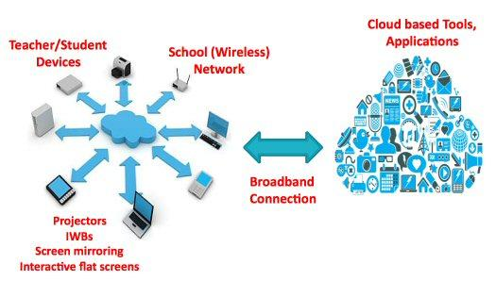
The implications of this for any school is clear. The underlying IT network that supports these innovative educational advances must be a cost-effective investment today, while also extending value into the future as a platform for new technologies now entering the educational space.
Core Recommendations
- Recognise that education networks are critical components of schools' infrastructures
- Recognise that 1-to-1 programs are quickly becoming the mainstream and plan accordingly
- Start network planning and upgrade processes by consulting with teachers and administrators
- Understand that accessing content and resources is just as critical outside of the classroom as inside
- Ensure that rigorous security measures are built into your network designs
- Make future-focused design choices in terms of scalability and adaptability
Plan for density
Students carry multiple mobile devices which are either school provided or their own (BYOD). Adding teacher devices, classroom tools like projectors and printers, and all sorts of new IoT devices, means planning for density is planning for success.
Strong Foundations are Built to Last
Build your IT as you would a building – ensure the network foundations are fit for purpose, that the system can adapt and is built to last. ‘Buyer’s remorse’ once you’re up and running, particularly with multi-site operations, will be costly and disruptive – take the time to build it right first time.

What are the most important factors you will add to your schools strategy document?

Important factors to consider when planning and building ICT Infrastructure
Cloud based tools and applications
Schools are increasingly using a wide range of useful cloud-based tools and applications to support teaching and learning. Many are free and provide a diverse and evolving range of possibilities to enhance learning.
Broadband
Broadband often is dependent on availability from regional providers. However most school might have the opportunity to find the right provider in the market for their needs, since fast, reliable broadband is critical to accessing online resources for learning. The speed of the network matters and so it’s critical to determine what is required to support instructors teaching style, including mobile devices. The modern classroom is an interactive space fostering collaborative learning, digital problem solving and increased student engagement. Key to this development is the need for reliable and adequate broadband throughout the school.
Cheap, or entry-level model, access points designed to support 5 or 10 users is going to have disastrous results if deployed in a school environment.
As a minimum, schools have high speed 100Mbit/sec broadband.

Mobile Learning Devices / Bring your own device (BYOD)
Increasing numbers of schools are now using mobile devices in classrooms in preference to desktop PCs. Also tablets are being purchased increasingly in preference to laptops as they provide schools with alternative options to support mobile learning.
A shift which is gaining momentum is to allow pupils to bring in their own devices (BYOD) for learning. If you open up for BYOD, the school should develop their BYOD policy. IT departments must address if and how they will secure personal devices and determine access levels. Most importantly, a defined BYOD security policy should inform and educate employees on how to employ BYOD without compromising organizational data or networks.
Important elements of BYOD policies include:
- Types of approved devices
- Security and data ownership policies
- Levels of IT support granted to personal devices (if any)
A strong BYOD security policy should be integrated with overall IT security and acceptable use policies. As IT leaders determine the level of support they will apply to personal devices, they must ensure a balance between organizational security and employees’ personal privacy.
Wireless / Wi-fi Networks
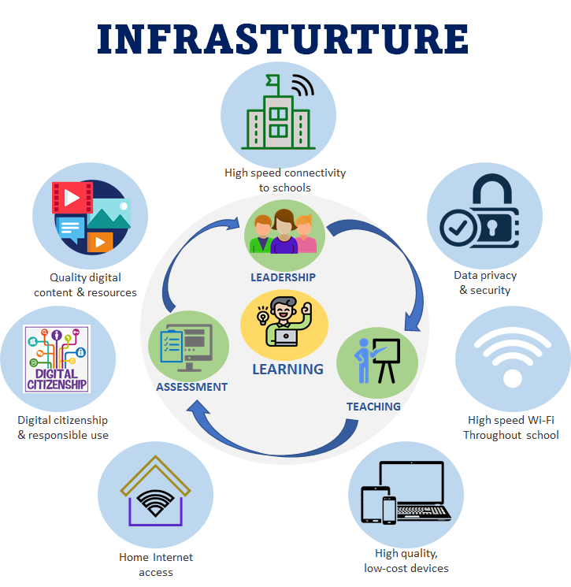
To support effective learning using mobile devices a ‘fit for purpose’ wi-fi network is now critical in schools. Wi-fi systems connect mobile devices to online resources via the broadband connection and as such mobile learning, school wi-fi, broadband and use of cloud applications are all inter-dependent. It is important that if schools are purchasing a wireless network that they seek independent advice.
As students roam between access points, their devices can get stuck on an AP instead of associating with a closer one that has a stronger signal. The ideal network infrastructure should eliminate this so that older generation devices or a disproportional distribution of users doesn’t drag down the network.
Adjust LAN access to support this new generation of access points. To avoid bottlenecks and cabling rework, upgrade to access switches that support 2.5 G/5G ports (with PoE) and 10G uplinks.

Presenting in the Classroom
Teachers are using a range of interactive approaches for ‘presenting’ in classrooms. While interactive whiteboards (IWBs) are still fit for purpose when used effectively, technologies such as Apple TV/Chrome Cast or other mirroring approaches can enable teacher or student screens to be mirrored wirelessly to a large screen. Also, large interactive flat screens (though more expensive to purchase) can provide an alternative to IWBs and/or a projector for new purchases.
Learning management system (LMS)
A LMS is a single shared ecosystem that unifies educators, students, and parents. When schools begin their preliminary research in the learning management system space, it is easy to become quickly overwhelmed with the amount of available products, all with their distinct and most notable features. Whichever product ends up being selected, it will be important to stay focused on how this new system will fit into your current school ecosystem. Some important factors to consider is:
- The LMS must be user-friendly
Don’t buy a product offering much more functionality that your schools need.
- The LMS should align with your school’s goals and technology strategy
If you don’t have a technology strategy that is aligned to the school’s learning goals, then consider making one.
- The LMS should provide efficiency to teaching and learning
- The LMS must integrate with other services and tools
Integration can provide a seamless and efficient experience for students and teachers.
- Before selecting a new LMS, get feedback from staff and students
Let the teacher’s trialing these systems in their classrooms, with their students.
- Check the system’s security, privacy, and data management features.
It’s vital to protect your school’s, students’, and teachers’ privacy.
- Verify that it fits your budget.

What are the most important ICT Infrastructure factors you will add to your schools strategy document?

